Web Services Testing Report

# 1. GitHub API (REST)

## a. URL of the Web Service:

- `https://api.github.com`

## b. What does the Web Service do?

- The GitHub REST API allows you to access information about users, repositories, commits, and more. For this test, we retrieve details about a user’s repositories and their followers.

## c. Messages sent and received:

### Test 1: List Repositories for a User

**Request**:

**GET** [**https://api.github.com/users/{username}/repos**](https://api.github.com/users/%7busername%7d/repos)

**Example**: `https://api.github.com/users/CodeWizard-404/repos`

**Response**:

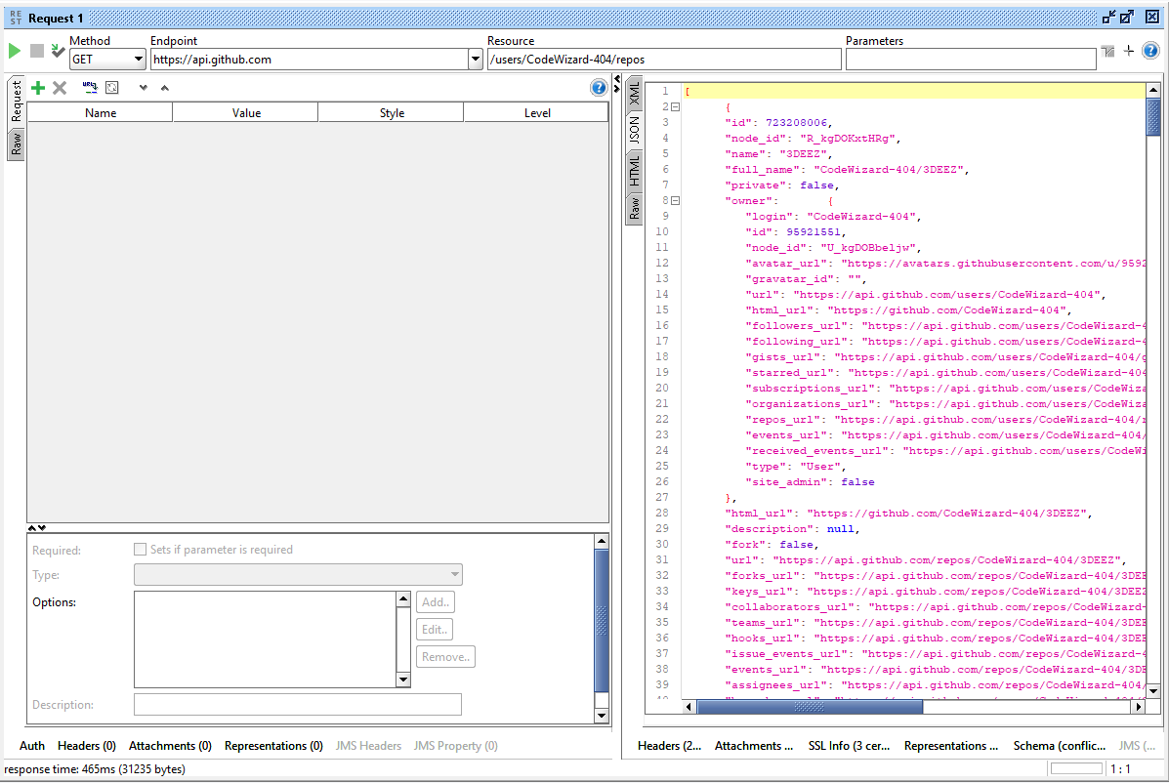

### Test 2: Get Repository Details

**Request**:

**GET** [**https://api.github.com/repos/{owner}/{repo}**](https://api.github.com/repos/%7bowner%7d/%7brepo%7d)

**Example**: `https://api.github.com/repos/CodeWizard-404/3DEEZ`

**Response**:

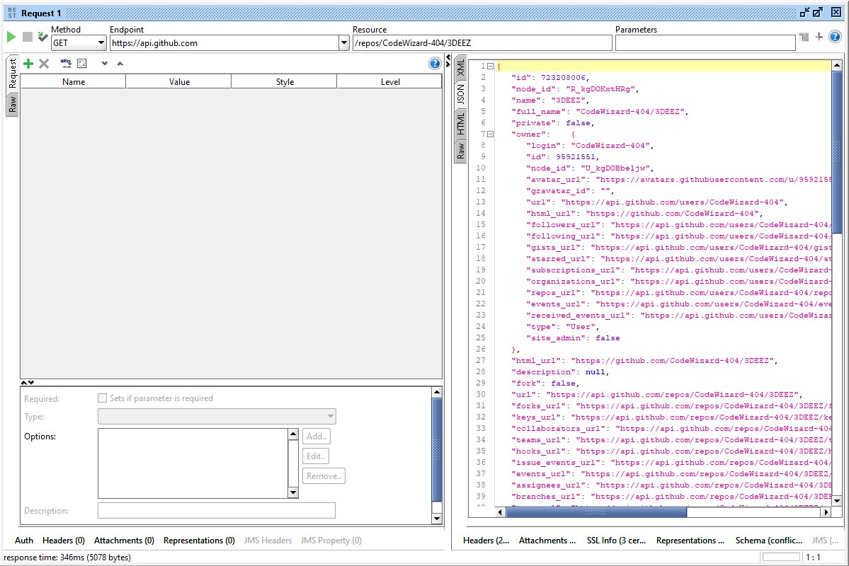

### Test 3: List User's Followers

**Request**:

**GET** [**https://api.github.com/users/{username}/followers**](https://api.github.com/users/%7busername%7d/followers)

**Example**: `https://api.github.com/users/CodeWizard-404/followers`

**Response**:

# 2. Number converter (SOAP)

## a. URL of the Web Service:

- **WSDL URL**: ` https://www.dataaccess.com/webservicesserver/numberconversion.wso?WSDL `

## b. What does the Web Service do?

- This web service provides functionality to convert a numeric input into its equivalent number name (e.g., 123 becomes "one hundred twenty-three") and its dollar amount in words (e.g., 123.45 becomes "one hundred twenty-three dollars and forty-five cents").

## c. Messages sent and received:

### Test 1: convert Number to dollars

**Request:**

* **SOAP Action:** ConvertNumToDollars

**Response:**

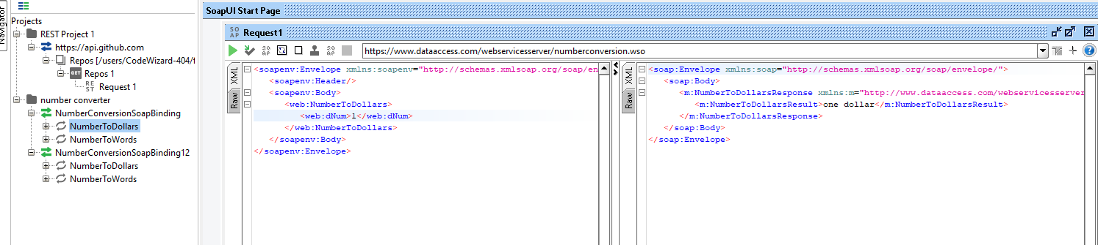

### Test 2: convert Number to Words

**Request:**

* **SOAP Action:** ConvertNumToWords

**Response:**

